# Walta-logo.jpg

# Little WALTA Style guide / Workflow

General

**Font:**  Tahoma or screen readable san serif equivalent

**Background colour:** white #ffffff

**Blue:** #2f61cc

**Gradient:**  blue (#2f61cc ) to white (#ffffff)

Anchor Bar



Stays on screen throughout whole app while in landscape mode.

1. Home button - takes you back to home screen from anywhere in app.
2. Top anchor bar - blue gradient (#2f61cc to #ffffff).
3. Section heading - Top level name of section stays throughout whole section. Font: Tahoma, centered.
4. Settings button. Takes you to setup & contact info.
5. Help/info button. Takes you to same section as "help" button on home screen.

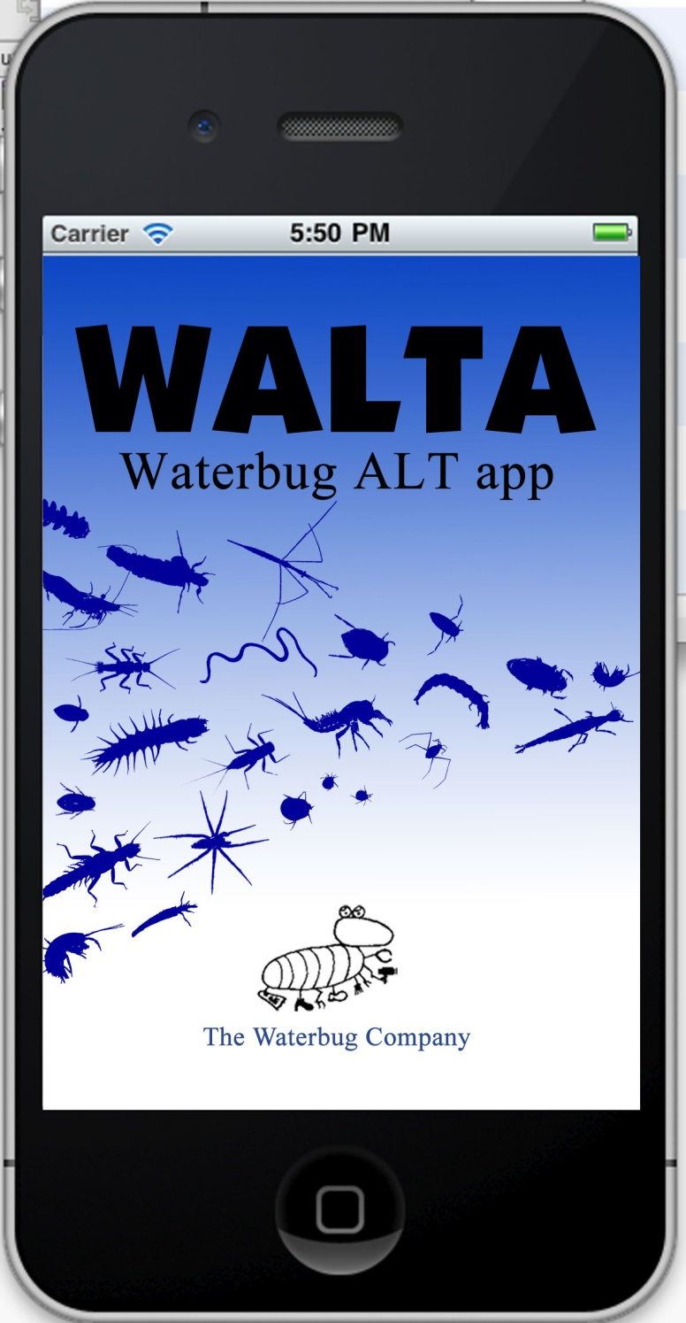Launch screen

**Description:** Screen that launches at startup, remains for about 2-3 seconds, then moves on to home screen. No links or hot sections needed.

Home screen

**Description:** Main screen for the app. This is the screen that the home button goes back to. Background colour of boxes is #cfdbf3.

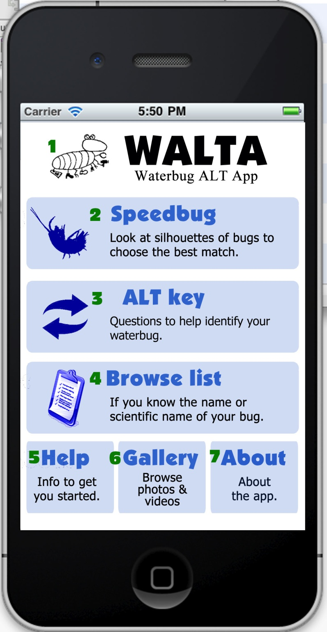

Entire blue section of each button is linked.

1. Walta logo. No link intended at this time, but it could also go to the about section.
2. Speedbug. Not in use in stage one.
3. ALT key - starts the ALT section off (see page 3)
4. Browse list. Not in use in stage one.
5. Help - goes to
6. glossary of terms and icons
7. more stuff
8. Gallery - goes to links to photos and videos in alphabetical order
9. About - goes to
10. Waterbug company info
11. contact details
12. Build number

About screen

**Description:** About screen for the app.

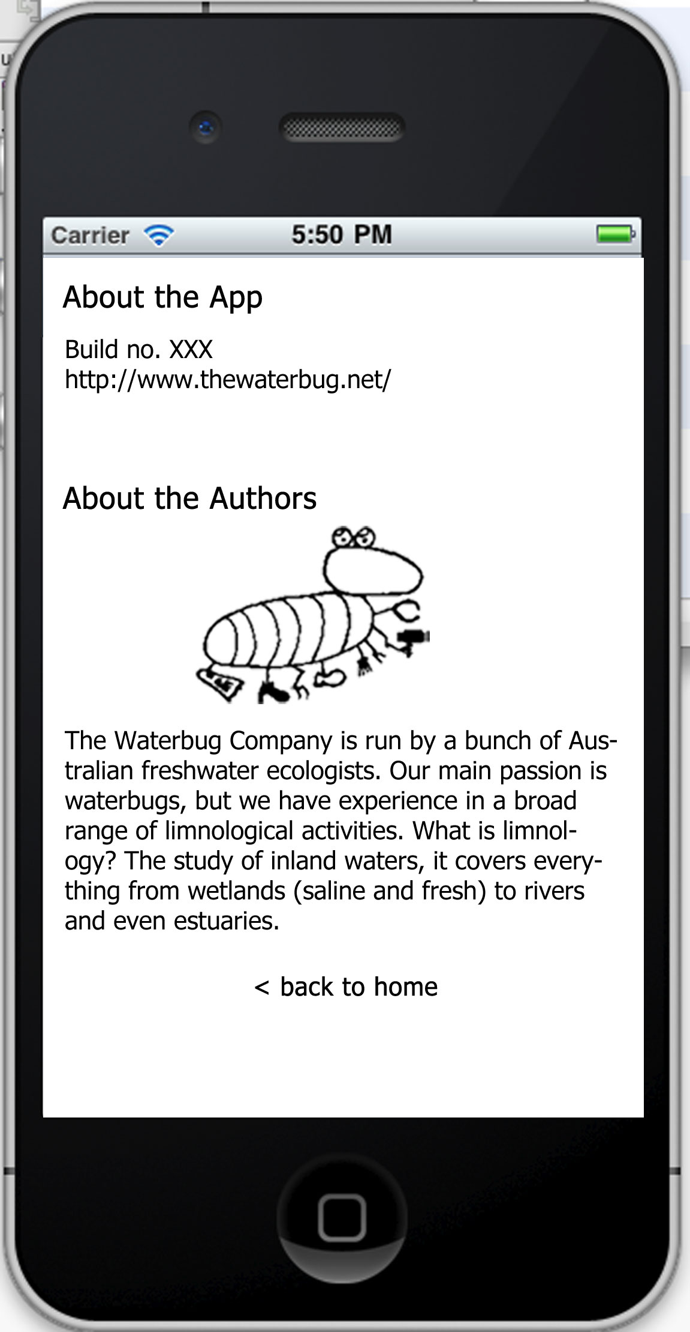

Lists the version number of the app and any info needed there.

Logo and about info.

Link back to home screen.

Glossary home screen

**Description:** Glossary screen for the app.



Links to each section of the glossary

Glossary terms screen

**Description:** Glossary of terms screen for the app. Listed in alphabetical order in one long scrolling screen. No plans for a search at this stage.

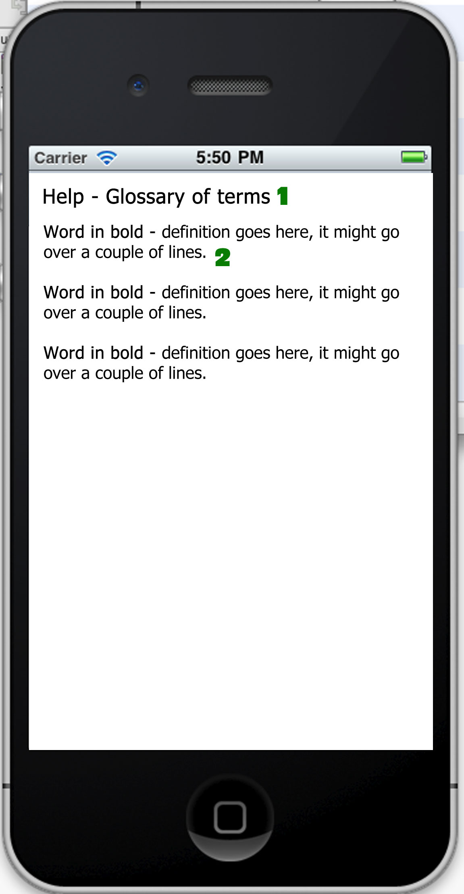

1. heading larger in bold, aligned left
2. definitions with word in bold and definition after it.

Glossary icons screen

**Description:** Glossary of icons screen for the app. Listed in alphabetical order in one long scrolling screen. No plans for a search at this stage.

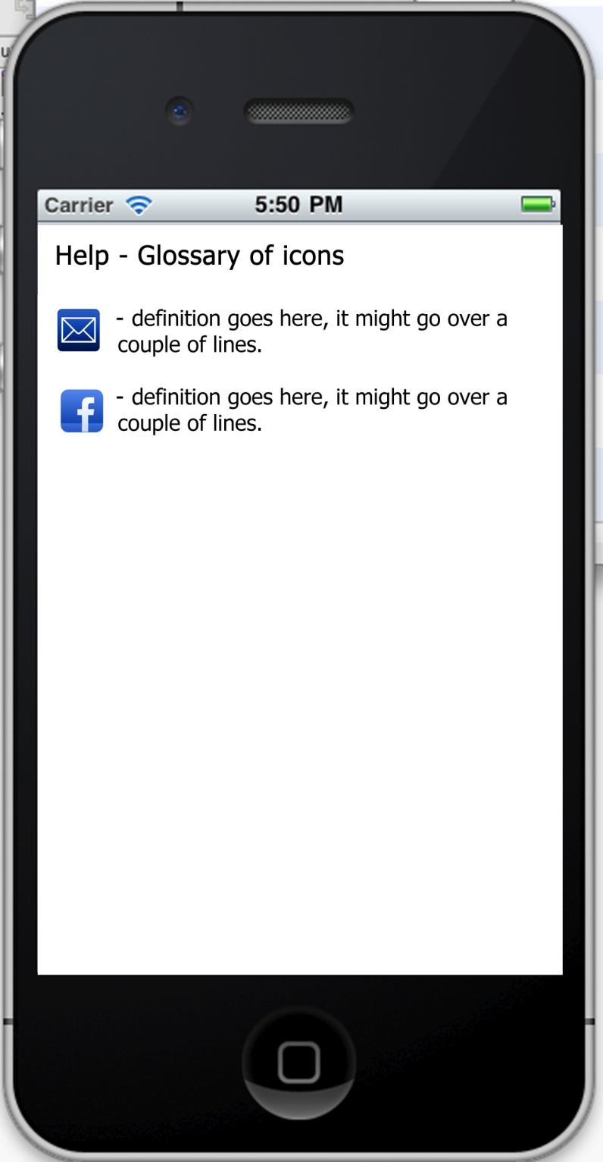

1. heading larger in bold
2. picture of icon on left and definition after it.

ALT key in progress

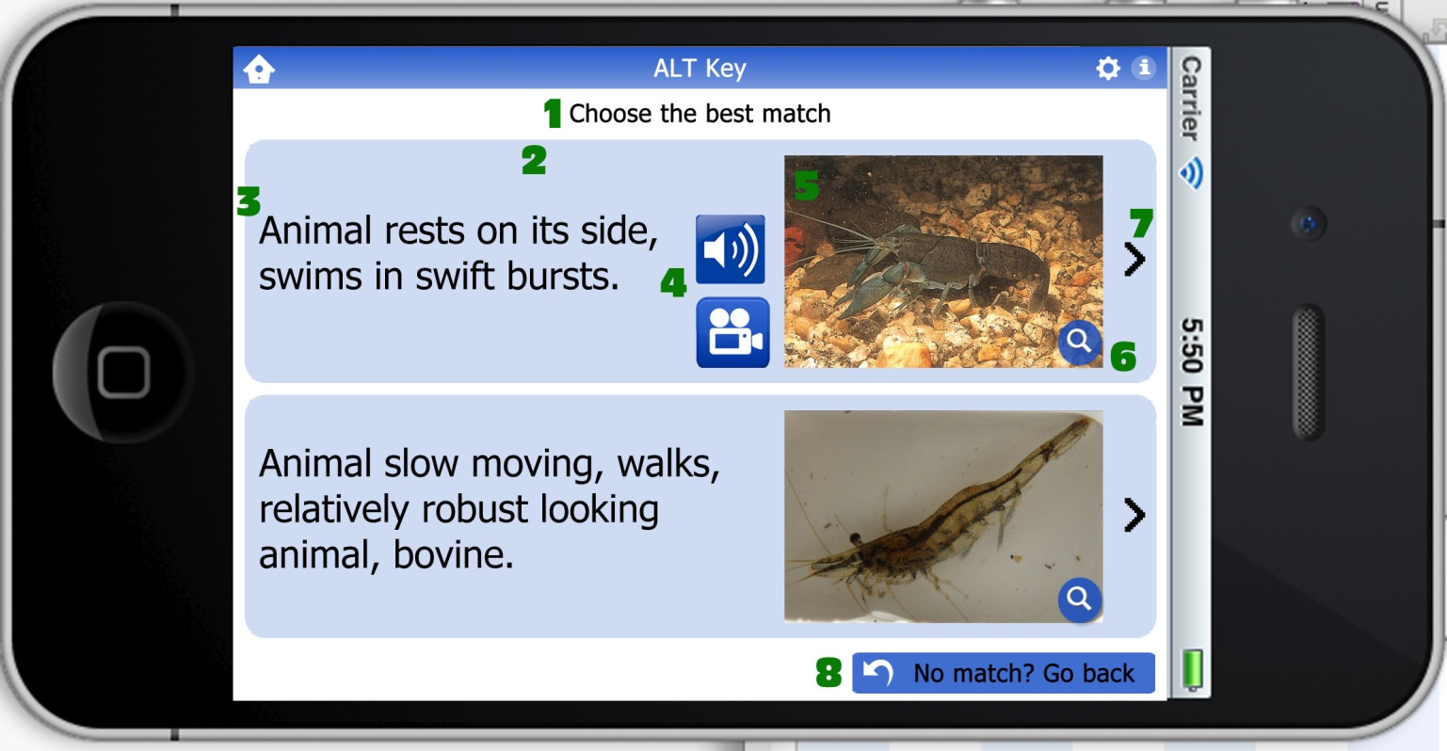**Description:** Main screen for the app. This is the screen that the home button goes back to. Entire blue area of each section is linked.

1. Page heading - centered
2. Section background - whole blue section is a hot key to the next section
3. Description - Aligned left, vertically aligned to the centre of the blue box.
4. Audio & Video icons - will only show up if info is available
5. Image - will only show up if image is available
6. Magnify link - whole image, including magnify button, will link to larger version of image (and full gallery if other images are available - see page 4)
7. Right arrow - indicates that there is a next section. Also linked, along with rest of blue section.
8. Start again button - takes you back to start of ALT section.

ALT key gallery

**Description:** What happens when you tap on the magnify link on an image. Tap on the images again to return to previous page.

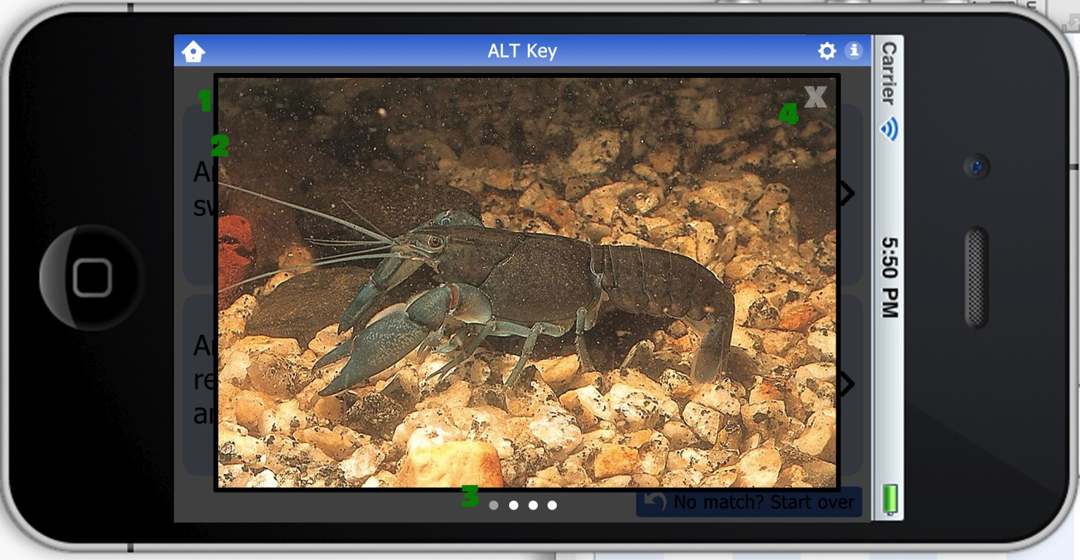

1. Large version of image opens in overlay. Background is greyed out to make it more visible.
2. Thick black border around image
3. Dots indicate how many images in gallery. Grey dot indicates which image you are viewing.
4. Close image button, takes you back to screen below

ALT key video

**Description:** What happens when you tap on the magnify link on an image. Tap on the images again to return to previous page.

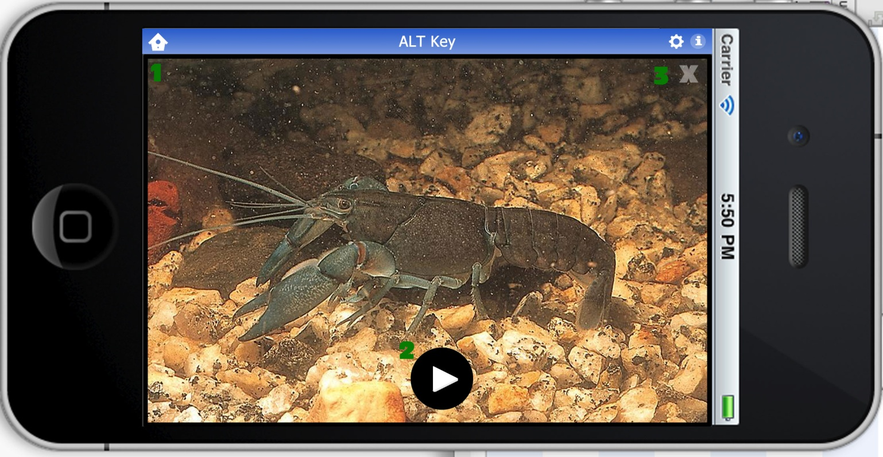

1. Video is full screen
2. Play button, turns to Pause while playing
3. Close image button, takes you back to screen below

ALT key final screen

**Description:** The final results screen of the ALT section.

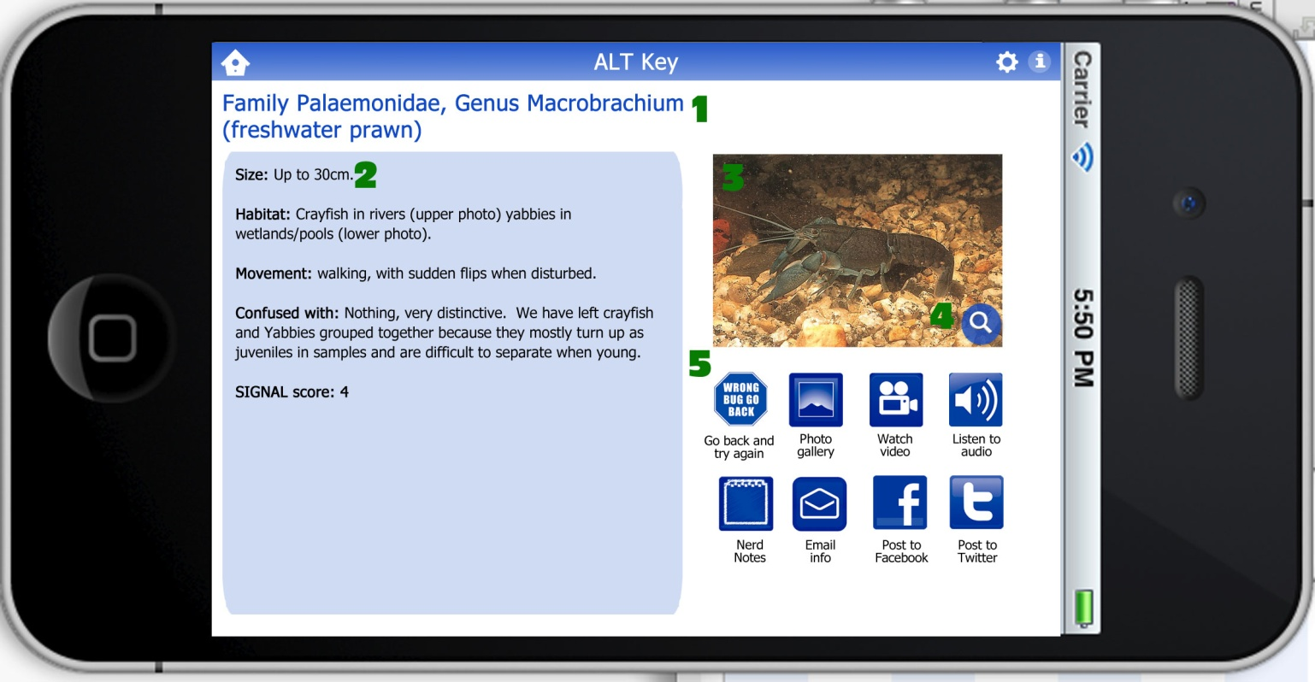

1. Heading - Name & scientificy bug name. Blue (#2f61cc). Left aligned.
2. Description - info about the bug.
3. Image - will only show up if image is available
4. Magnify link - whole image, including magnify button, will link to larger version of image (and full gallery if other images are available) - see page 5
5. Icons - should align to left and fall to next line if available.
6. Wrong bug go back
7. Photo gallery - does same as magnify link above (item 3)
8. Video icon - only appears if video is present
9. Audio icon - only appears if audio is present
10. Nerd Notes
11. Email icon - email info to yourself or others
12. Facebook - posts results to your facebook page
13. Twitter- posts results to your twitter account